umass
Volume
1
Product Support & Technologies
Manually Update Cache
Product support & technologies
Manually Update Cache
© UMASS
100 Century Dr.
Worcester Ma, 01615
Phone 508.856.8200

Table of Contents

Chapter 1 3
Summary 5

Chapter 1
Chapter
1
In this chapter you’ll find information on how to manually update cache.
When the data store needs to be updated through the back end it will become necessary to synchronize the web servers cached memory objects with the new data in the data store. The following out lines the steps necessary to update the web servers cache for just one of these occasions. The following instructions will apply for any application where the “Base Application” has been used as the foundation for a project.
First you will need an account that belongs to the “SysAdmin” role; generally speaking there will be at least one account. Use the select state link and choose state “XX”. Delete all of the files.
Logon to the system. | 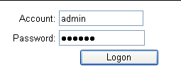
Use the select a state module.
Select the state “XX” | 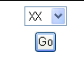
Use the link to the file manager.
Use the “Select All” button. | 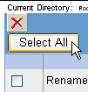
Click the delete button. | 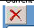
Repeat this process until all of the files have been deleted.
Note: You may not be able to delete all of the files, when the system needs to build a portion of the cache a file will be put into this directory.

Summary
Due to the nature of the application your UI could look very different, even the names of the modules could change (darn that flexibility), but the idea should be the same.
Just incase this does not work the directory your looking to delete files from is the “CacheDependency” directory. Please don’t delete the directory itself just the files in it.
Good luck to all.

